

Functional Test Plan – AP/Relay Firmware 5.4.3
CitiPower Pty Ltd and Powercor Australia Ltd
Insert Document Reference

Disclaimer
The master document is controlled electronically.
Ensure latest version prior to use.

Based on CPPAL Style Guide, CPPAL-TP-0001 CPPAL Style Template Revision 231117
Document controlled in accordance with ST-1750 INMS Document Management Standard

Document Control
Reviewer | Signature | Date
Kamau Njuguna
Communication Networks Laboratory Technician
Graeme Watson
Senior AMI Strategy Engineer
Karl Ngo
Metering Engineer
Wayne Sangsukdee
AMI Communications Analyst

Approver | Signature | Date
Stuart Bannister
Communication Networks Manager
Goutham Lingam
Metering Asset Manager

Version | Amendment Overview | Author
1 | Initial Version | Leonard Jarillas  Manager Communication Networks Quality  08/04/2024

Table of Contents
1. Overview 1
1.1 Background 1
1.2 Goals and Objectives 1
1.3 Document Purpose 1
1.4 Related Documents 2
1.5 Terms, Definitions and Acronyms 2
2. Scope of Testing 4
2.1 In Scope 4
2.2 Out of Scope 4
3. Test Strategy 6
3.1 Test Categories 6
3.2 Test Cases Preparation 7
3.3 Test Execution 7
3.4 Defect Management 8
3.4.1 Defect and Issue Escalation Process 8
3.4.2 Defect Status Meetings 8
3.5 Test Results and Reporting 8
3.6 Test Closure 9
3.7 Continuous Improvement 9
3.8 Roles and Responsibilities 9
4. Test Considerations 10
4.1 Testing Assumptions 10
4.2 Test Data 10
4.3 Environment 10
4.4 Software Requirements 10
4.5 Hardware and Firmware 11
4.6 Testing Tools 11
4.7 Testing Location 11
4.8 Risks and Mitigation Strategies 12
5. Test Schedule 12
6. Entry / Exit Criteria 12
6.1 Entry Criteria 12
6.2 Exit Criteria 13
6.3 Testing Location 13
7. Landscape Page 14
Appendix A: CP Appendix Heading 1 Style 15
A.1 CP Appendix Heading 2 15
A.1.1 CP Appendix Heading 3 15

List of Figures
Figure 1: Test and deployment strategy 6

List of Tables
Example of List of Tables
Table 1: Related Documents 2
Table 3: Roles and Responsibilities 9
Table 4: Testing Assumptions 10
Table 5: Test Environments 10
Table 6: Test and Deployment Schedule 12

- Overview
  - Background

With the imminent shutdown of the Telstra 3G network, VPN and UE has replaced, or in the process of replacing, all AP1.5 and AP4.5, that only support 3G, with AP5 that supports 4G.

An issue was identified on some AP5 that has been deployed in the production network wherein the AP5 would lose WAN (Telstra-side) communication but still has NAN (mesh) communication. This issue has been acknowledged by Itron in their Product Information Letter PIL-23-1584 Potential Loss of Communication to Access Point (AP) 5.0 with Some Carrier Networks.

This issue has been addressed in the AP firmware 5.4.2. With the latest firmware release being 5.4.3, it has been decided to take 5.4.3 in order to get the other benefits or enhancements available in 5.4.3.

  - Goals and Objectives

The main goal of the functional acceptance testing for the Itron Gen 5 AP and Relay firmware 5.4.3 is to ensure that all AP and relay deployed in UE and VPN network can be upgraded to firmware 5.4.3 with minimal risk to the business. To achieve this goal, the following objectives should be met by the end of the test project:
- Perform comprehensive testing to verify that all critical functions of the access point and relay are operational and meets the business’ requirements after upgrading to firmware 5.4.3
- Ensure that the AP and relay firmware 5.4.3 is compatible with the endpoint NIC firmware (3.12.9, 3.12.9c, 3.12.9b, 4.8.2c) deployed in the production network
- Capture all defects found, if any, during testing and understand the risk that they present to the business

Although one of the objectives of the test project is to verify that existing defects has been fixed, some defects are very hard to replicate and is almost improbable to verify. An example of this is PIL-23-1584 since it has a large dependency on the Telstra network and when the AP5 will initiate an IP change.

  - Document Purpose

The purpose of this document is to define the Functional Acceptance Test Plan for the Itron Gen 5 AP and Relay firmware 5.4.3. This document will define how testing for the project will proceed, who will be involved in the testing, what will be tested, how much time the test will take and to what quality level the test will be performed. It will outline any processes for escalation and reporting of test findings.

This document also acts as a guide on the testing process and helps clarify the following:
- Objectives
- Scope
- Test approach and methodology
- Test activities
- Entry and Exit Criteria
- Test Schedule
- Test environment
- Roles and responsibilities
- Risk Management

This document is intended for the following stakeholders:
- Network Communications Quality team (TAG)
- Network Communications manager
- Metering Asset Manager
  - Related Documents

Table 1: Related Documents
Document | Filename (Link/Location) | Input /Output /Reference
DPI AMI Specifications | DPI Minimum AMI Functionality Specification (Victoria) 1.1 | Reference
CHED Interpretation on DPI Specifications | CHED_interpretation_VIC_MAFS_r1.1_ver0.1.doc | Reference
PIL-23-1584 | PIL-23-1584_Potential_Loss_of_Communication_to_Access_Point_(AP)_5.0_with_Some_Carrier_Networks.pdf | Reference
Firmware release notes | UtilOS_Firmware_5.4.05.4.3_Release_Notes.pdf | Reference

  - Terms, Definitions and Acronyms

Term | Description
AMI | Advanced Metering Infrastructure
AP | Access Point
CHED | CHED Services Pty Ltd – part of CHEDHA CKI/HEH Electricity Distribution Holdings (Australia) Pty Ltd. CKI and HEH are Cheung Kong Infrastructure Holdings Ltd and Hong Kong Electric Holdings Ltd respectively
CP | CitiPower Pty Ltd
PAL | Powercor Australia Limited
UE | Uniter Energy
QC | Hewlett Packard Application Lifecycle Management Quality Centre – test management software
SIT | System Integration Testing
SSN | Silver Springs Network
UIQ | Utility IQ Application
CATT | Communications Tester
FAT | Functional Acceptance Testing
FSU | Field Service Unit
TAG | Technology Assurance Group (Network Communications Quality team)
AEMC | Australian Energy Market Commission
NER | National Electricity Rules
HAN | Home Area Network
IHD | In Home Display

- Scope of Testing
  - In Scope

The following items will be covered in the Functional Acceptance Testing.

- Access Points
  - AP5
- Relay
  - Relay5
  - Relay1.5
  - Relay4.5
- Meters
  - Single phase: 10ML1,11ML3, 12ML5, 12MP1
  - Three-phase direct connect: 31ML1, 31MP, 31ML3
  - Three-phase CT: C0ML1, C0MP1
- NIC types
  - NIC2, firmware 3.12.9
  - NIC3, firmware 3.12.9c
  - NIC5, firmware 4.8.2c
- FSU5 and Communication Tester 7.6.9
- Meter to NIC Combinations (subject to meter availability)
  - 10ML1-NIC2 (U1200)
  - 11ML3-NIC3 (U1300)
  - 12ML5-NIC5 (U1300)
  - 31ML1-NIC2 (U3300)
  - 31ML5-NIC5 (U3400)
  - C0ML1-NIC3 (U3350)
  - CAT1-NIC2 (PACT)
  - CAT3-NIC3 (PACT)
  - CAT5-NIC2 (PACT)
  - CAT6-NIC3 (PACT)
  - CAT1-NIC5 (DLMS)

  - Out of Scope

The following items are not covered in the Functional Acceptance Testing.
- User Acceptance Testing
- Performance testing including compliance to the performance level requirement in the DPI specification
- NMS functionality that are not related to NIC firmware (i.e. Meter metrology and export of meter events)
- Integration testing to other systems other than NMS
- HAN integration to UIQ. HAN testing is limited to IHD able to retrieve data from the meter and it’s NIC.
- microAP
- Mechanical and regulatory compliance requirements

- Test Strategy

To accelerate field deployment of the firmware, the test strategy below shall be implemented for both AP5 and relay firmware. This will follow the proposed field deployment schedule to minimise the risk in production environment.

With this, the AP5 firmware can be deployed on the filed after all critical tests on it are finished and with no reliance on the result of the relay firmware testing as there is no urgency to deploy the new firmware to the relays. Production verification is also being done in parallel of the remaining non-critical tests.

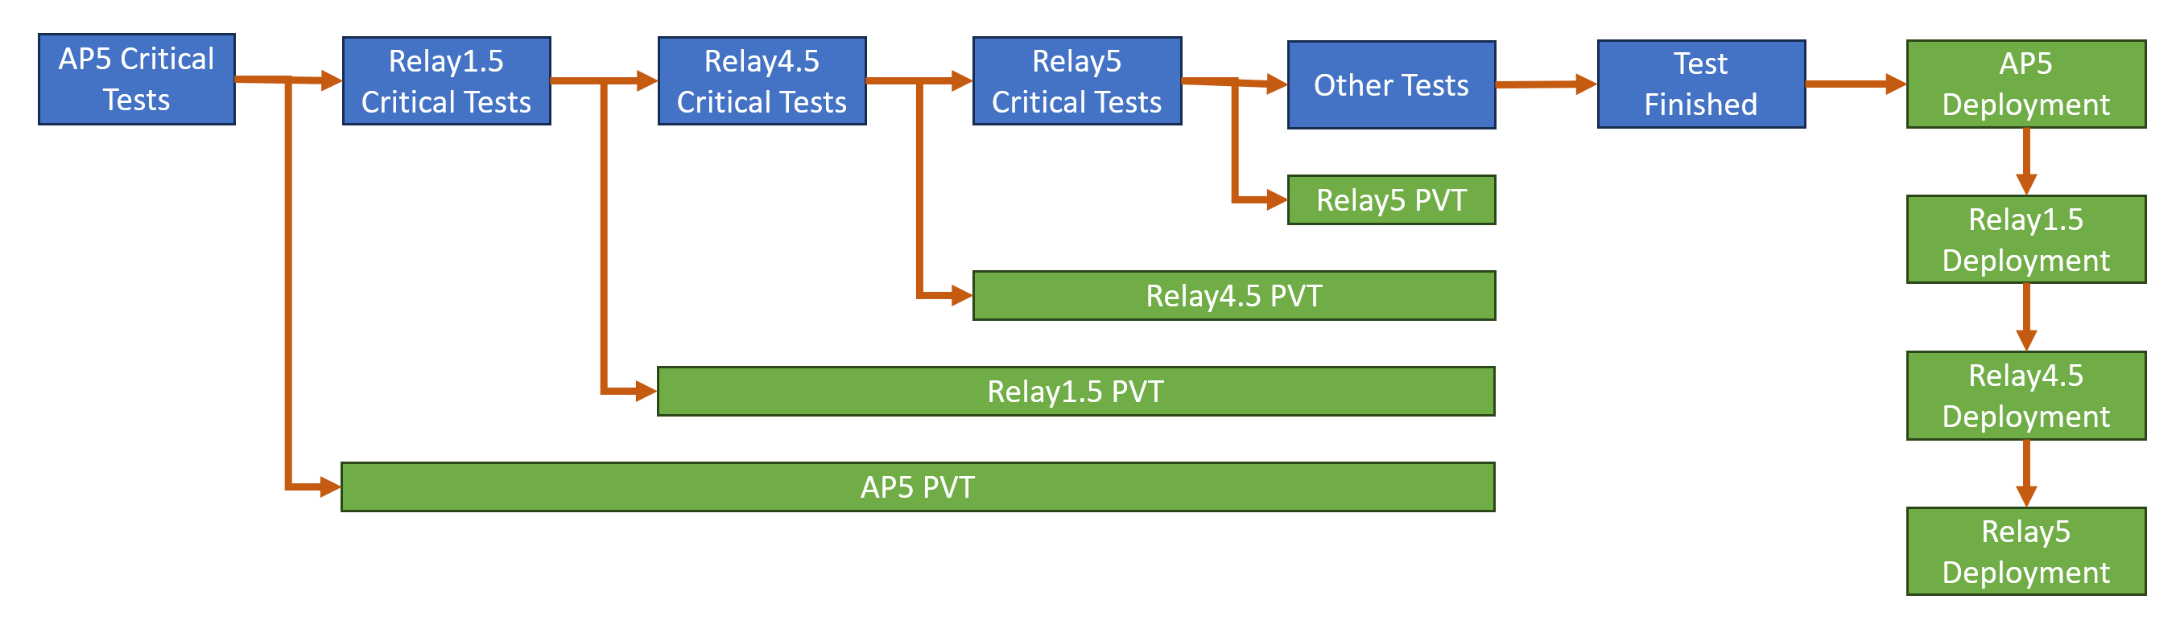

Figure 1: Test and deployment strategy

  - Test Categories
The test cases are divided into different priorities that will define the order of testing.
- Critical tests: These are the test cases that are non-negotiable due to regulatory and business requirements. These test cases also include those use cases that are encountered and used in the day to day operation of the meters in production environment. An example of this are remote firmware update, meter programming, metrology, supply contactor functionality.
- Supplementary Tests: These are test cases that are similar to critical tests, but with alternative settings and configurations. This is to check if test object meets regulatory and business requirement in broader term. E.g.: ESCC test with non-Prod settings, Auto Disconnect with non-prod yet not extreme settings, QoS polling with longer polling interval or different polling values, etc.
- Edge Cases: These test cases are those that may occur during the life of the meter but needs some specific sequence of events or conditions. An example is the meter has powered off during the auto-disconnect period.
- Exploratory tests: These are exploratory tests to investigate how the firmware under test will behave under specific circumstances. These are edge cases that have no test cases yet.

The test cases are also grouped according to functionality. Within these groups are several test cases that may fall into different priorities as stated above.
- Networking
- Firmware Update
- Metering Data Integrity
- Supply and Load Contactor
- Meter Programming
- New requirements/functions
- Supply Capacity Control
- Alarms and Events
- Additional
  - Test Cases Preparation

Additional requirements shall be solicited from relevant stakeholders and brainstormed within TAG. New test cases shall be written to for these additional requirements.

Existing test cases from previous NIC firmware test projects shall be re-used for existing requirements.

All test cases shall be uploaded to HP QC under the NC_Quality project.

  - Test Execution

In order to minimize the number of communication path combination that needs to be tested whilst taking minimal risk, the meter-relay-AP testing combination to be used on each test cycle is shown below.

All critical tests shall be done on Meter-AP5 path and selected critical tests shall be done through the Meter-Relay-AP5 path. This will test both direct connection and hops.

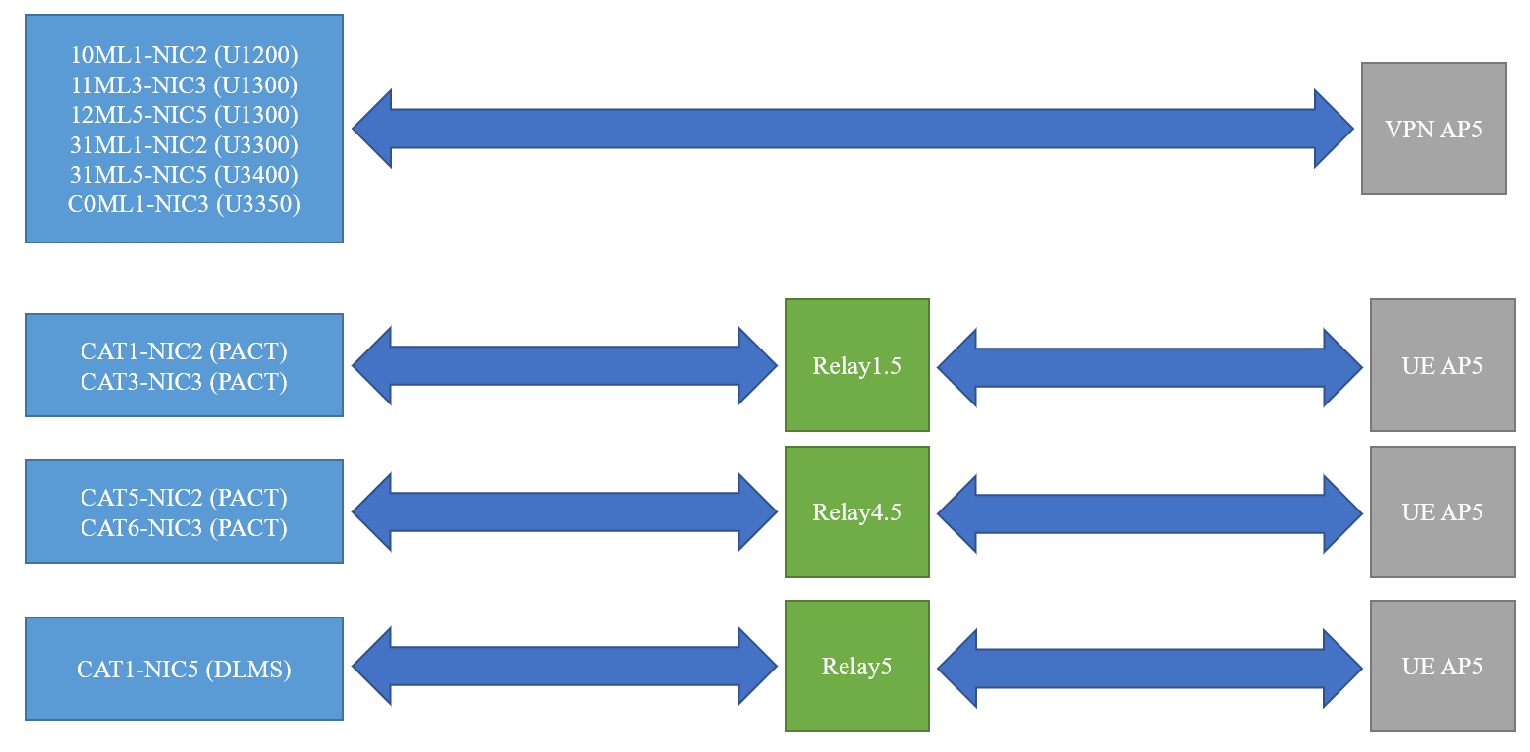

  - Defect Management

One of the main objectives of the test project is to ensure that the device under test satisfy the business requirements. This entails finding any unexpected behaviour of the device to be able to manage the risk associated with it.

A discrepancy between the expected result and actual result in a test case is a defect. Although the tester should be aware that some of the test cases are generic tests and he/she must make a decision if the difference between the expected and actual result is in fact a defect. An example of this is when testing a test case wherein the described expected result is for a Secure meter when the meter under test is an L&G meter.

The defect register to be used by this project shall be the HP QC/ALM defect register.
- All defects identified will be raised and managed in Quality Center (QC).
- Defects will be captured in the NC_Quality database. All defects uncovered during test execution will be assigned to the Test Manager.
- The key defect attribute is the Severity. This attribute impacts exit criteria and effort prioritisation. Other attributes can be managed by the testing team as required.
- Defects within the NC_Quality QC project should fill up the following fields:
  - Project: 2024 - AP_Relay 5.4.3
  - Detected in Cycle: <fill in test cycle>
  - Device Type:
  - Device Firmware:

    - Defect and Issue Escalation Process

Defect and issue escalation raises visibility of defects and issues to appropriate levels when normal resolution processes have not been successful. The most common reason for escalation is failure to agree on defect severity and resolution times with the vendor or other teams (i.e. UIQ Support).

The Test Lead is responsible for escalating defect issues to the Test Manager where necessary. The Test Manager will review the issue, and where appropriate will work with the responsible team and/or vendor at an appropriate level to obtain a timely resolution; otherwise escalation continues to the Network Communications Manager. The escalated defect issue will be monitored closely and regular defect status meetings should ensure that it does not affect the progress of testing as well as completion time.

    - Defect Status Meetings

A defect status meeting will be called if stakeholders raise concerns on defect reports that cannot be resolve via online, email or phone discussions. Defect meetings will be run by the Test Manager and will be attended by the following:
- Communications Network Quality Manager
- Communications Network Operations Manager
- Test Lead
- Metering Asset Management representative
- UIQ Support representative (if needed)
- Vendor representative (if required)

  - Test Results and Reporting

All test results shall be documented and recorded in HP QC/ALM.

Weekly progress and defect management reports shall be created by the test lead and submitted to the test manager for review and reporting to the wider business.

  - Test Closure

The functional acceptance and regression test shall be considered finish when all the exit criteria specified below has been met.

  - Continuous Improvement

All members of the test team should keep in mind about continuous improvement. Any feedback on test plans, test processes, defect management, test execution, findings and lessons learnt during the tests shall be recorded in the Project Feedback Register as they are thought of. This would ensure that the ideas are recorded immediately and not lost. The Project Feedback Register shall be reviewed weekly and any improvements that can be impact the project shall be implemented immediately (i.e. test case improvement from U1300 test that can be applied on the U3400).
The test manager shall schedule a post implementation review at the most one week after the closure of the project. The result of this review shall be communicated to the members of TAG and other teams involved during the test to serve as a guide on the next test project.

  - Roles and Responsibilities
The table below lists the roles and responsibilities of those involved in this test project.

Table 2: Roles and Responsibilities
Name | Role | Responsibility
Leonard Jarillas | Test Manager/Test Lead | - Vendor engagement and management from the test perspective  - Project escalation point for any project related issues that cannot be resolved by the project team or the Test Lead  - Test progress reporting to stakeholders  - Testing resource allocation throughout the project  - Ensure fully configured testing environments are in place for testing  - Approve project specific test plans, test cases and Test Certificate  - Escalation point for issues with test related activities.
Kamau Njuguna | Tester | - Prepare test cases as per specifications (if required)  - Test execution  - Document and log defects found during testing  - Help test lead to prepare project specific test documentation, which includes the Test Plan and Test Certificate  - Help test lead to write progress and defect reports

- Test Considerations
  - Testing Assumptions
A number of assumptions have been identified for testing activities. These have been listed below and are the basis for this approach defined in this document:

Table 3: Testing Assumptions
ID | Assumption
1 | Second variant of U1200 meters (10ML2, 11ML2, 12ML2) and U3300 (30ML2, 31ML2) perform exactly the same as the first variant based on historical test experiences.
2 | UIQ-DEV shall be available for the duration of the test project.
3 | The difference in the number of elements or the absence of the load contactor does not affect the testing result of the AP and Relay.
4 | The meter type has no material impact on the AP5 and Relay firmware as the meter message is wrapped within the mesh packet sent via the NIC.

  - Test Data
Test cases used in previous firmware test project shall be re-used. All test results shall be recorded in HP QC and will be used for progress reports.

  - Environment
The following applications and interfaces are required to perform the firmware test.

Table 4: Test Environments
System | Description
UIQ (DEV) | Network Management System used for remote reading and control of the meters. Most of the remote testing shall be done using UIQ.

  - Software Requirements
The following test tools are required to perform Functional Testing:

No | System | Requirements
1 | Quality Center (QC) | - Access to Domain: Testing_Services and Project: NC_Quality
2 | Web Browser | - CORP Supported Web browser installed on local Personal Computer (PC)
3 | MS Office Suite | - Microsoft Office suite for reporting, test preparation, data preparation and management of testing;  - Microsoft Outlook for communication with relevant parties or stakeholders regarding scheduling of outages, data refreshes deployment and work dissemination.
4 | SnagIt | - To capture images for defects and test results into Quality Center.

  - Hardware and Firmware

Category | Types | FW Version
PE Cell | SELC External CMS | - 05.00.02  - 05.00.03
Access Points | Gen 5 | - 4.8.6002  - 5.4.6040  - 5.4.6043
Relay | Gen1.5  Gen4.5  Gen 5 | - 3.12.5009  - 3.12.6009  - 4.8.6002  - 5.4.6043
NIC | ARM (NIC 2)  AKIO (NIC 3)  RNI (NIC 5) | - 3.12.9  - 3.12.9c  - 4.8.2
FSU | 5

  - Testing Tools

Category | Activity | Tool Name
Local | Local configuration, monitoring and operation | - CATT

  - Testing Location

All tests will be executed in the AMI Lab at 7 Cahir Court, Brooklyn VIC 3012.

The HP QC/ALM location will be:

Domain: Testing_Services
Project: NC_Quality
Path: Test Lab -> Root\VPN\2024 - AP_Relay FW 5.4.3

  - Risks and Mitigation Strategies

The following are considered as risks that will affect the test project.
All risks which are assessed as having high probability and high impact should have a detailed Action and Implementation plan developed.

# | Risk Description | Consequence | Likelihood | Rating | Mitigation Strategy / Action | Owner
1 | UIQ-Dev environment not available during testing causing delay on test completion | Moderate | Low | Low | - Transfer tests to other environments  - Raise high priority ticket to UIQ Support | - Testers  - Test Manager
2 | Lack of testing resources leading to delay on test completion | High | Low | Low | - Plan for alternate resources (ACCG) | - Test Manager

- Test Schedule

Table 5: Test and Deployment Schedule
- Entry / Exit Criteria
  - Entry Criteria
- Acceptance test plan (this document) reviewed and endorsed by stakeholders
- HP QC test folders has been setup
- Test hardware, Firmware and all necessary software has been delivered by the vendor
- CATT has been installed on all the machines to be used by the testers

  - Exit Criteria
- 100% of test cases in HP QC has been executed
- All defects has been raised in HP QC and has the associated vendor defect id
- No outstanding severity 1 or severity 2 defects
- Maximum of 10 outstanding severity 3 or 4 defects, with at most 5 of these at severity 3. All Severity 3 defects should be acknowledge by the vendor and have a schedule in place for a permanent fix
- Severity for open defects discussed and agreed with the stakeholders
- Test Certificate document signed off by all appropriate stakeholders (approvers of Test Plan)

  - Testing Location
All tests will be executed in the AMI Lab at 7 Cahir Court, Brooklyn VIC 3012

  - Test Instances

Using the 2-element single phase meters and three-phase meters with load control covers all meter types for the purposes of this test project. This also reduces the number of combinations that needs to be tested. It is not expected that the difference in the number of elements or the absence of the load contactor will affect the testing of the AP and Relay. Second variant of U1200 meters (10ML2, 11ML2, 12ML2) are also not be included in the testing with the assumption that they perform exactly the same as the first variant. This is based on historical test experiences.

